Bonding Activity Part IV: Comparing Lewis Dot Diagrams for Ionic and Covalent Bonds

A- Ionic Bonds.
Step 1. Form 6 pairs of atoms that will make an ionic bond based on the electronegativity scale. Fill in column A.
Step 2. Then draw their Lewis dot diagrams in column B for this ionic bond, with the metal drawn first, followed by the nonmetal.
Step 3. Determine how many of each element there should be based on the charge of both ions. If you use more than one of the same element to match up unpaired electrons, as seen in the second example, you note how many with a coefficient in front of that ion. When you add up all of the charges, it should equal zero.
Check charges:
(+2) + (-2) = 0

(+2) + 2(-1) = 0
A. Number and element that will form an ionic bond | B. Lewis Dot Diagram for ionic bonds
1 Barium (metal) and  1 Oxygen (nonmetal) | 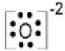  Ba ²⁺
1 Barium (metal) and  2 Chlorine (nonmetal) | 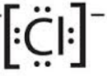  Ba ²⁺ 2
B- Covalent Bonds Levels 1-3
Level 1. Do Level 1 of Levels Game. Check your answers with answer key. If you receive a star on your paper by the teacher, write your name under Level 1 on the board and continue on to level 2.
Level 2. Repeat step 1, but with level 2 of the game.
Level 3. Repeat step 1, but with level 3 of the game.

C- Covalent Bonds Level 4-6
Level 4. On to Level 4! Using your cards, form 3 pairs of atoms that will have nonpolar covalent bonds according to the electronegativity difference scale. Fill in column A.
Draw the Lewis dot diagrams for these compounds in column B just like what you did for Level 1 of the game in part B above.
A. Pair of atoms that will form an ionic bond (label metal or nonmetal) | B. Lewis Dot Diagram for ionic bonds
bromine (nonmetal) and  bromine (nonmetal) | 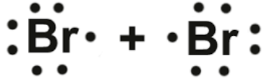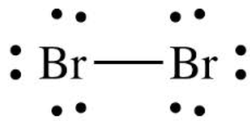

Level 5. Now Level 5! Just like level 4 but form polar covalent bonds and do 4 of them.
A. Pair of atoms that will form an ionic bond (label metal or nonmetal) | B. Lewis Dot Diagram for ionic bonds
hydrogen (nonmetal) and
bromine (nonmetal)

Level 6. Finally, Level 6! Just like level 5 but for covalent bonds with 3 or more nonmetal atoms and do 6 of them. **Hint: Start with an atom that has more than one unpaired electron and then find other atoms that have one unpaired electron to pair up.
A. 3 or more nonmetal atoms that will form covalent bonds. | B. Lewis Dot Diagram for this molecular compound.
Hydrogen  Hydrogen  Oxygen | 