Stations: Bonding Types (Ionic, Nonpolar Covalent, Polar Covalent, Metallic)

What is a bond?
NOTES:
1. What is a chemical bond?

2. What is the process called when you break a chemical bond? ___________________________
3. How do you break a bond?

4. What is the process called when you make a chemical bond? ____________________________
5. How do you make a bond?

CHECK FOR UNDERSTANDING:
1. For the following chemical reaction is it an endothermic or exothermic process and how do you know?
2Na(s) + Cl₂(g) 2NaCl(s)

2. Draw the Lewis structure for sulfur and identify how many bonding sites (unpaired electrons) it has.

REGENTS PRACTICE QUESTIONS ON THE BACK
REGENTS PRACTICE QUESTIONS: Write a sentence that explains each of your answers for full credit.

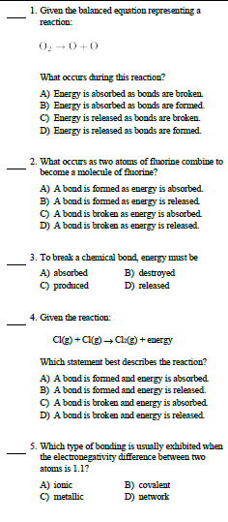

Ionic Bonds
NOTES:
1. When do ionic bonds form?

2. What is involved for ionic bonding to occur?

3. List 4 properties of ionic compounds.
a.
b.
c.
d.
4. Draw an example of how electrons are transferred from one atom to another. Be sure to draw the arrow that shows where an electron starts and ends up.

CHECK FOR UNDERSTANDING:
1. Draw the Lewis dot diagram for NaCl. Hint: First draw the ion form for Na and for Cl separately.

2. What type of elements make up ionic bonds?

REGENTS PRACTICE QUESTIONS ON THE BACK
REGENTS PRACTICE QUESTIONS: Write a sentence that explains each of your answers for full credit.

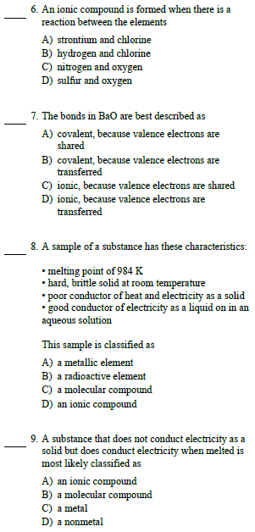

Covalent Bonds- Nonpolar vs Polar
NOTES:
1. When do covalent bonds form?

2. What type of elements (metals and/or nonmetals) form covalent bonds? _______________________
3. What are atoms that form covalent bonds called? _____________________________________
4. List 5 properties of molecular compounds.
a.
b.
c.
d.
e.
5. Name and define the two types of covalent bonds.
a. _______________________________________:

b. _______________________________________:

CHECK FOR UNDERSTANDING:
1. Why is HBr (hydrogen bromide) considered to have a polar covalent bond?

2. Why is Br₂ (diatomic bromine) considered to have a nonpolar covalent bond?

3. What is a double bond and a triple bond? Give an example of each.

REGENTS PRACTICE QUESTIONS ON THE BACK
REGENTS PRACTICE QUESTIONS: Write a sentence that explains each of your answers for full credit.

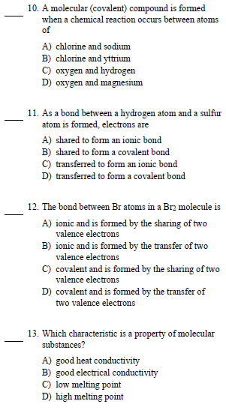

Metallic Bonding
NOTES:
1. What type of elements (metals and/or nonmetals) form metallic bonds? ______________________
2. Describe 2 properties of metallic atoms.
a.
b.
3. What does metallic bonding result from?

4. When does metallic bonding occur?

5. Draw a picture that represents metallic bonding.
6. List 3 properties of metallic elements.
a.
b.
c.

CHECK FOR UNDERSTANDING:
1. Which element has a crystalline lattice through which electrons flow freely?
A) Bromine B) Calcium C) Carbon D) Sulfur
2. Which element has properties of good electrical conductivity and luster and exists as a liquid?
A) Hg B) Br C) I C) C

REGENTS PRACTICE QUESTIONS ON THE BACK
REGENTS PRACTICE QUESTIONS: Write a sentence that explains each of your answers for full credit.

