VSEPR model: Valence Shell Electron-Pair Repulsion
Directions: Before beginning each station, complete this front page. Then, with your partner, rotate around to each of the 5 stations to learn about each structure in greater depth.

What is the purpose/postulates of the VSEPR model?
_________________________________________________________________________________________________________________________________________________________________________________________________________________________________________________________________________________________________________________________________________________________________________________________________________________________________________

Basic 5 forms of VSEPR
X + E | Overall Structure | Forms

KEY:
A =
X =
E =

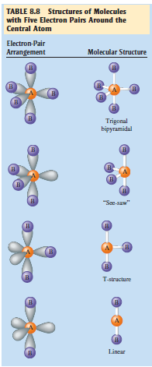
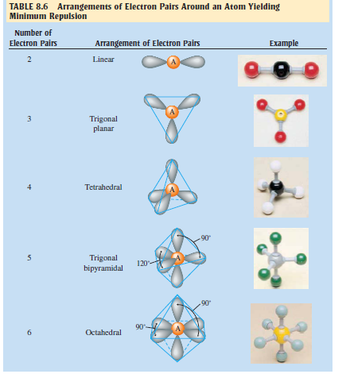

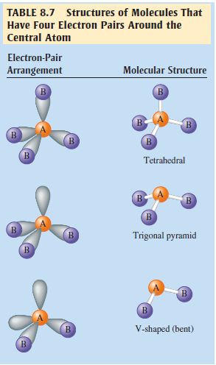

NOTE
You must memorize these structures and names for the ap exam.

Station 1. Linear
1. Draw the general VSEPR model for a linear structure. Color in the central atom and label the angles of the bonds accordingly.

2. Come up with 4 different molecules that you would predict to have a linear structure.
**Note: Ionic compounds will not form bonds like molecular compounds will because they do not share electrons through covalent bonds.
Symbol | Name | Lewis dot diagram | Molecular model
BeCl₂ | Beryllium chloride | 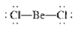 | 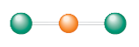  Cl  Be  Cl

Station 2. Trigonal Planar
1. Draw the general VSEPR model for a trigonal planar structure. Color in the central atom and label the angles of the bonds accordingly.

2. What does the word “planar” mean? _____________________________________________________________________________________3. Come up with 4 different molecules that you would predict to have a trigonal planar structure.
**Note: Ionic compounds will not form bonds like molecular compounds will because they do not share electrons through covalent bonds.
Symbol | Name | Lewis dot diagram | Molecular model
BF₃ | Boron Trifluoride | 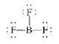 | 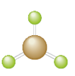  F  B  F  F

Station 3. Tetrahedral
1. Draw the general VSEPR model for a tetrahedral structure. Color in the central atom and label the angles of the bonds accordingly.
2. Compare and contrast a square planar structure from a tetrahedral structure and explain why a tetrahedral structure would be used over a square planar structure for methane (CH₄).
_______________________________________________________________________________________________________________________________________________________________________________________________________________________________________________________________
3. Come up with 4 different molecules that you would predict to have a tetrahedral structure.
**Note: Ionic compounds will not form bonds like molecular compounds will because they do not share electrons through covalent bonds.
Symbol | Name | Lewis dot diagram | Molecular model
CH₄ | Carbon Tetrahydride | 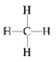 | 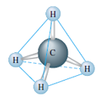

Station 4. Trigonal Bipyramidal
1. Draw the general VSEPR model for a trigonal bipyramidal structure. Color in the central atom and label the angles of the bonds accordingly.
2. How does the name “trigonal bipyramidal” help you determine and/or remember the shape of the structure?
_______________________________________________________________________________________________________________________________________________________________________________________________________________________________________________________________
3. Come up with 4 different molecules that you would predict to have a trigonal bipyramidal structure.
**Note: Ionic compounds will not form bonds like molecular compounds will because they do not share electrons through covalent bonds.
Symbol | Name | Lewis dot diagram | Molecular model
PCl₅ | Phosphorous pentachloride | 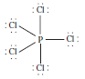 | 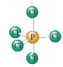

Station 5. Octahedral
1. Draw the general VSEPR model for an octahedral structure. Color in the central atom and label the angles of the bonds accordingly.
2. Explain why XeF₄ is considered to have an octahedral arrangement of electron pairs but a square planar molecular structure. Note: XeF4 is NOT described as being octahedral.

3. Come up with 3 different molecules that you would predict to have an octahedral structure.
**Note: Ionic compounds will not form bonds like molecular compounds will because they do not share electrons through covalent bonds.
Symbol | Name | Lewis dot diagram | Molecular model
[PCl₆]⁻ | Phosphorous hexachloride anion | 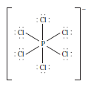 | 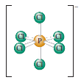

Post-Stations Summary Questions
Directions: Use what you have learned from the stations to answer the following three summary questions.

1. Explain the main postulate of the VSEPR model. List the five base geometries (along with bond angles) that most molecules or ions adopt to minimize electron-pair repulsions. Why are bond angles sometimes slightly less than predicted in actual molecules as compared to what is predicted by the VSEPR model?

2. Give two requirements that should be satisfied for a molecule to be polar. Explain why CF4 and XeF4 are nonpolar compounds (have no dipole moments) while SF4 is polar (has a dipole moment). Is CO2 polar? What about COS? Explain.

3. Consider the following compounds: CO2, SO2, KrF2, SO3, NF3, IF3, CF4, SF4, XeF4, PF5, IF5, and SCl6. These 12 compounds are all examples of different molecular structures. Draw the Lewis structures for each and predict the molecular structure. Predict the bond angles and the polarity of each. (A polar molecule has a dipole moment, while a nonpolar molecule does not.) Refer to the figures on page 2 of this packet for the molecular structures based on the trigonal bipyramid and the octahedral geometries.

