Lab #10: Polarity and Hydrogen Bonding

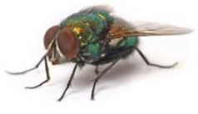
Phenomenon: Why can I fly walk on water?

To-Do List
- Make a staple float on water. (This will take patience and gentleness)
- Draw and describe what you see when the staple is floating in the box below.
- Tap the staple with your finger to make it sink.

Challenge:
- Make a paperclip float on water. (This will take patience and gentleness)
- Was this more or less difficult than the staple? Explain your answer in terms of what you had to do to be successful.

________________________________________________________________________________________________________________________________________________________________________________________________________________________________________________________________________________________________________________________
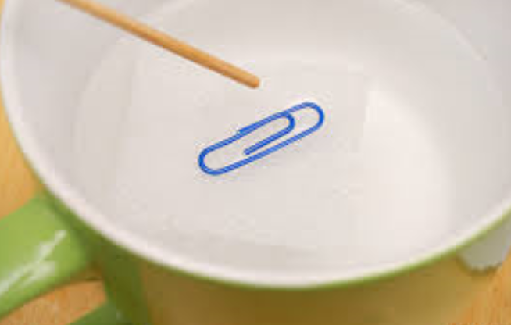

*Questions on the back*

Analysis Questions
1. Predict: How is it that a staple can both float and sink in water? Explain in terms of bonding and forces of attraction. (Note: Density would not be the answer because density for a given object does not change.)
_______________________________________________________________________________________________________________________________________________________________________________________________________________________________________________________________

2. How does a staple or paperclip floating on water connect with a fly walking on water?
_______________________________________________________________________________________________________________________________________________________________________________________________________________________________________________________________

3. Based on your observations of the staple/paperclip, do you think a fly could sink in water? If so, what could cause this to happen?
_______________________________________________________________________________________________________________________________________________________________________________________________________________________________________________________________

Phenomenon: How do you bend water?

To-Do List
- Assign roles: Designate one person to hold the buret (long, thin tube) over the sink and another person to hold the balloon.
- Charge the balloon by rubbing it against a fleece or wool piece of clothing. (Jeans may also work if you rub it with some force.)
- Use the graduated cylinder to carefully fill the buret with water (make sure the switch is turned horizontally (closed). Put the buret over the sink and turn the switch vertically on the buret for a steady stream of water and hold the charged balloon close to this stream of water, but DO NOT TOUCH THE WATER WITH THE BALLOON. If this happens, dry and recharge the balloon.
- Diagram and describe what you observe in the box below. If nothing happened, try again and then call the teacher over.
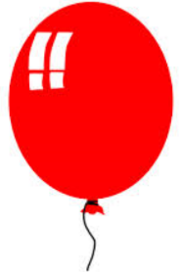

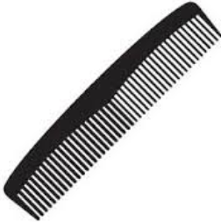

Challenge:
- Repeat the steps from above, but this time, use a charged plastic comb.
- Was this more or less difficult than the staple? Explain your answer in terms of what you had to do to be successful.

________________________________________________________________________________________________________________________________________________________________________________________________________________________________________________________________________________________________________________________

*Questions on the back*

Analysis Questions
1. Draw the Lewis dot diagram for H₂O.

2. Why do you think H2O is called a bent molecule? What causes the H₂O molecule to be bent?
_______________________________________________________________________________________________________________________________________________________________________________________________________________________________________________________________

3. Predict: H2O has a positively charged end and a negatively charged end. Using a + and a – symbol, label your Lewis dot diagram above with where you think the partially positive end is with a + and the partially negative end with a -. Explain why you labeled it this way.
_______________________________________________________________________________________________________________________________________________________________________________________________________________________________________________________________

Predict: Thinking about the shape of the H₂O molecules and the charged objects, come up with an explanation for what you observed with the comb and the balloon next to the water.
_________________________________________________________________________________________________________________________________________________________________________________________________________________________________________________________________________________________________________________________________________________________________________________________________________________________________________

Challenge: How many drops of water can a penny hold?

To-Do List
- Use the plastic pipette to put 10 drops of water on the surface of a penny.
- Draw and describe what you see in the box below. Be sure to LABEL your drawing.
- Tap the water on the penny with your finger and describe what happens on the lines next to the box below.
__________________________________________
__________________________________________
__________________________________________
__________________________________________
__________________________________________
__________________________________________

Challenge:
- How many drops of water can you fit on the surface of a penny? Count carefully!
- Was this more or less difficult than the staple? Explain your answer in terms of what you had to do to be successful.
__________________________________________________________________________________________________________________________________________________________________________________________________________________________________________

*Questions on the back*

Analysis Questions
1. Draw the Lewis dot diagram for H₂O. (It should look bent if you did it correctly.)

2. Molecules containing nonmetals like water are covalently bonded and can be either polar or nonpolar. A molecule that is polar is asymmetrical (not symmetrical), meaning you can not fold the molecule in half both vertically and horizontally and still have symmetry. A nonpolar molecule is the opposite, meaning you can fold the molecule in half both vertically and horizontally and have symmetry. For example, a triangle would be asymmetrical and a square would be symmetrical.

Asymmetrical (polar) Symmetrical (nonpolar)

Using this information and your Lewis dot diagram, is H₂O ia polar molecule or a nonpolar molecule? Explain your answer in terms of symmetry.
_______________________________________________________________________________________________________________________________________________________________________________________________________________________________________________________________

3. Predict: Why can a penny hold so many drops of water on such a small surface? What properties of water allow this to happen?
_______________________________________________________________________________________________________________________________________________________________________________________________________________________________________________________________

POST-LAB (as a class)
5 Types of bonds
1. Ionic bonding
2. Polar covalent bonding
3. Nonpolar covalent bonding
4. Metallic bonding
5. Hydrogen bonding

HYDROGEN BONDING
http://ed.ted.com/lessons/how-polarity-makes-water-behave-strangely-christina-kleinberg#watch

Directions: Read over the questions below before watching the video so you know what to look out for. Then take notes during the video to help you remember what you saw. The video will be played twice.

Notes:
1. Table salt (NaCl) is an ionic compound. As with other ionic compounds, NaCl dissolves in water. When placed in water, Na and Cl form ions. Na has a positive charge and Cl has a negative charge. Describe how water molecules interact with these ions.

2. If you drop a metal paperclip into a cup of water, it will sink to the bottom. However, with practice, you can gently place a metal paperclip on the surface of the water and it will balance or appear to float. Explain why this happens.

3. Polarity refers to the _______________ in a molecule.
A) Unequal sharing of protons
B) Unequal sharing of electrons
C) Equal sharing of protons
D) Equal sharing of electrons

4. Which of the statements below correctly describes the partial charges on the atoms in a water molecule?
A) All the atoms act as if they have a positive charge.
B) All the atoms act as if they have a negative charge.
C) The oxygen atom acts as if it has a positive charge while the hydrogen atoms act as if they have a negative charge.
D) The oxygen atom acts as if it has a negative charge while the hydrogen atoms act as if they have a positive charge.

5. What type of bonds exists between neighboring water molecules?
A) Ionic bonds
B) Hydrogen bonds
C) Polar covalent bonds
D) Nonpolar covalent bonds

