Stations: Types of Chemical Reactions and Solution Stoichiometry (ch. 4)

Precipitations Reactions
NOTES
- What four things must you know to determine if a precipitation reaction will occur? *summarize!*

- Write down the solubility rules. You must remember these as they are not given to you.
CHECK FOR UNDERSTANDING
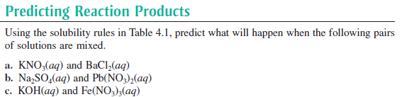

AP PRACTICE QUESTIONS
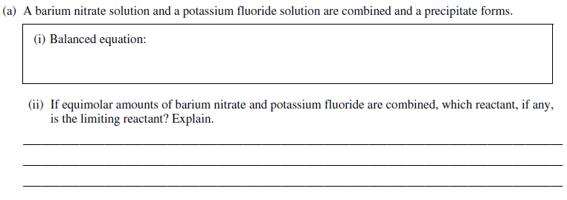

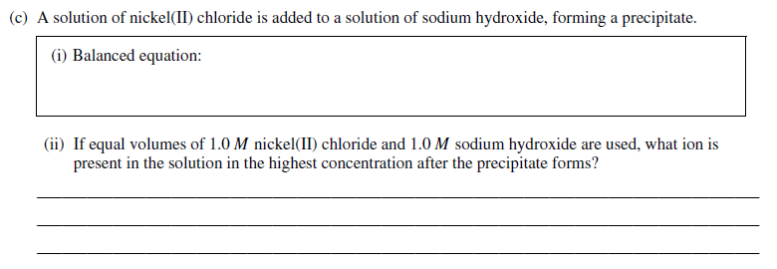

Describing Reactions in Solutions
NOTES
- Define the following terms:
  - Strong electrolyte
  - Formula equation
  - Complete ionic equation
  - Net ionic equation
  - Spectator ions

CHECK FOR UNDERSTANDING
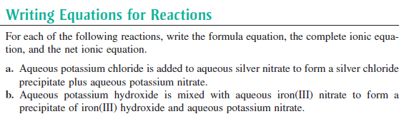

AP PRACTICE QUESTIONS
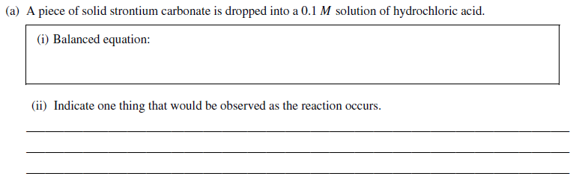

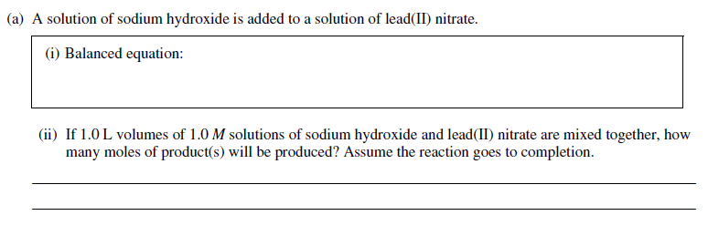

Acid/Base Reactions
NOTES
- Compare and contrast Arrehenius’s concept of an acid and a base and Bronsted and Lowry’s definition.

- Describe how the products in the equation below were formed/determined.

- What are the steps needed to calculate reactants and products in an acid-base reaction.

CHECK FOR UNDERSTANDING
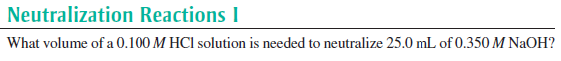

AP PRACTICE QUESTIONS
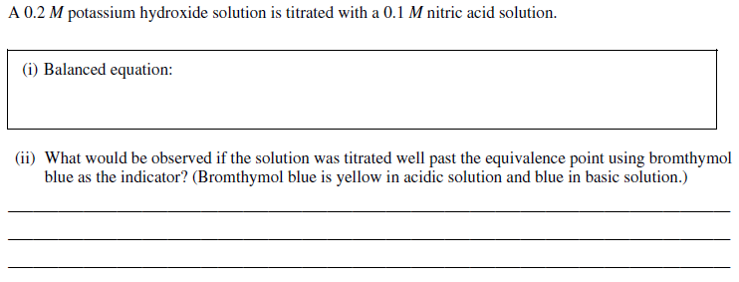
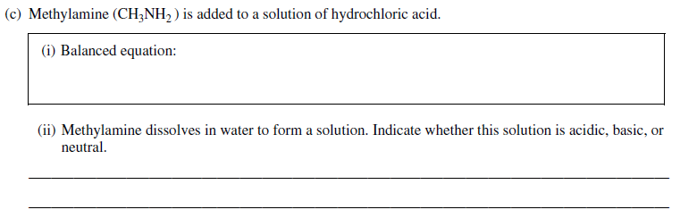

Redox Reactions
NOTES
- Define the following terms:
  - Redox reaction
  - Reduction
  - Oxidation
  - Oxidation number (state)
  - Oxidizing agent
  - Reducing agent

- What are the rules for assigning oxidation states? (Note: there are two slides with the same info on them but in different formats)

CHECK FOR UNDERSTANDING
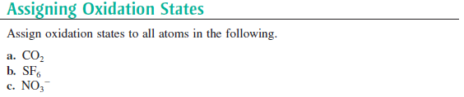

AP PRACTICE QUESTIONS
