AP Chemistry – ThermoChem Quiz
Directions: You will have exactly 25 minutes to take this 20 point quiz. Note: You may want to start with question 2, as it is worth more points.

Question 1. [5 points]
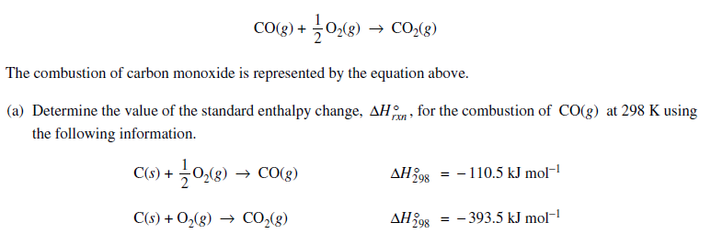

Question 2. [15 points]
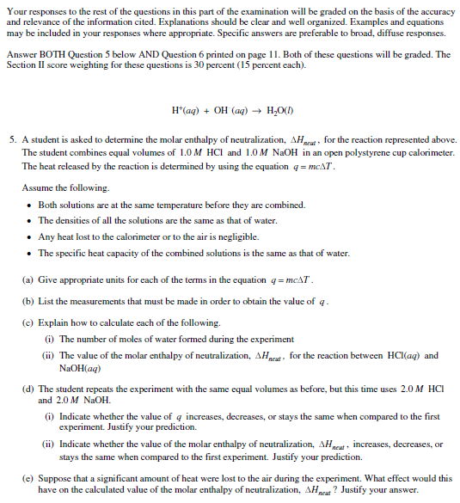

Answer Question 2 here.

