STOICHIOMETRY TEST REVIEW

Test Information
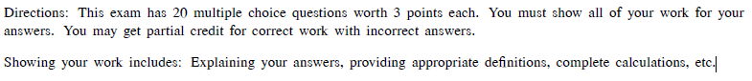
Stations Directions: Start with the stations you feel are most challenging for you. Take the necessary notes you will need to complete this station. The questions given to you mirror the questions that are on the actual test.

Station 1: Mass, Moles, Molecules

Take necessary notes for this station in this box.

Answer the following questions and show all necessary work.
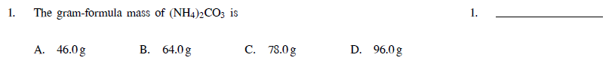

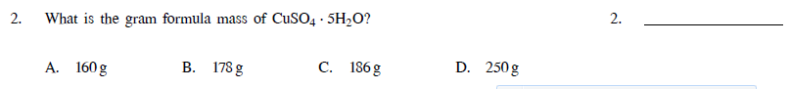

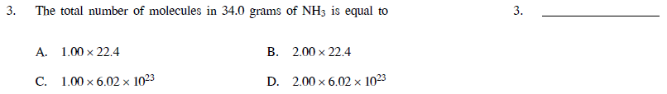

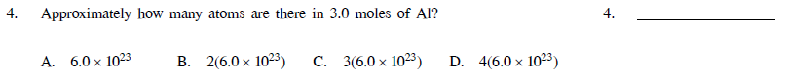

Station 2: Percent Composition

Take necessary notes for this station in this box.

Answer the following questions and show all necessary work.

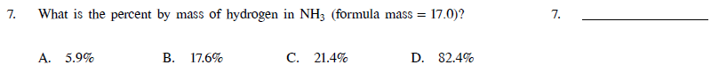

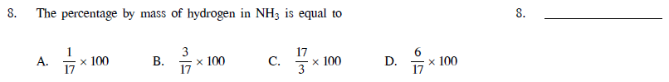

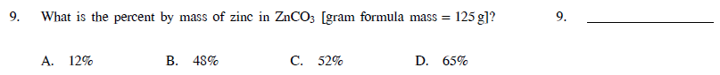

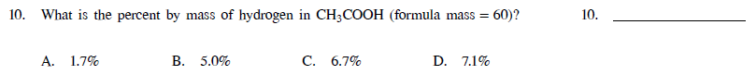

Station 3: Empirical and Molecular Formulas

Take necessary notes for this station in this box.

Answer the questions on the next page and show all work.

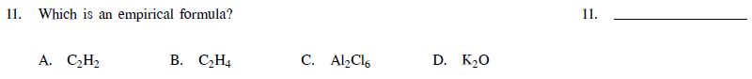
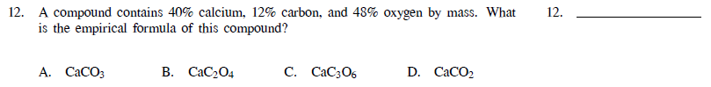

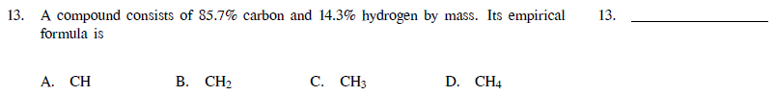

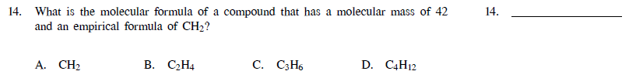

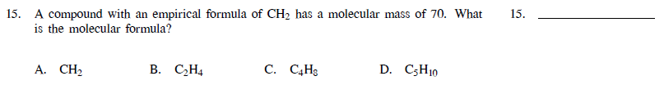

Station 4: Reaction Types

Take necessary notes for this station in this box.

Answer the questions on the next page and explain your answers.

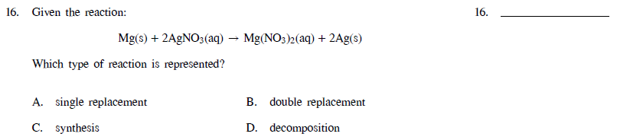

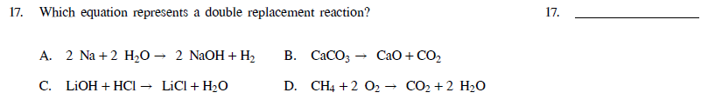

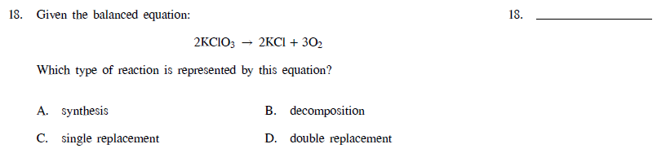

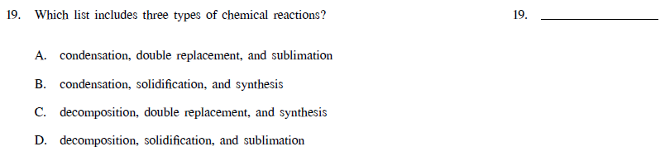

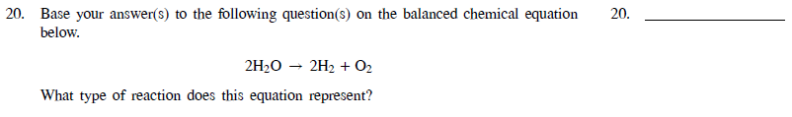

Station 5: Mole Ratios

Take necessary notes for this station in this box.

Answer the questions on the next page and show your work.

