LAB 14: SOLUTIONS AND DILUTIONS

Part 1: Making a solution
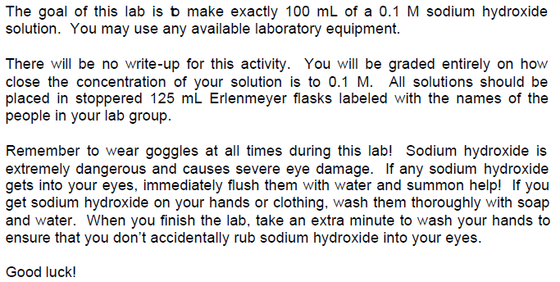
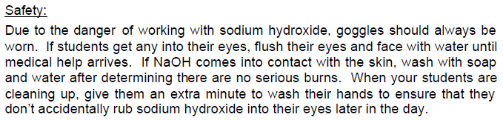
Procedure:
Write down your calculations and procuedure in a series of numbered and detailed steps:
______________________________________________________________________________________________________________________________________________________________________________________________________________________________________________________________________________________________________________________________________________________________________________________________________________________________________________________________________________________________________________________________________________________________________________________________________________________________________________________________________________________________________________________________

Part 2: Making a dilution
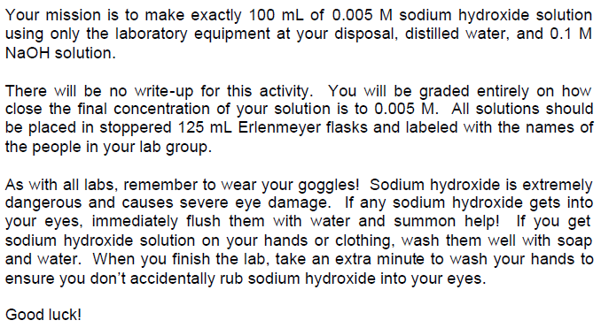
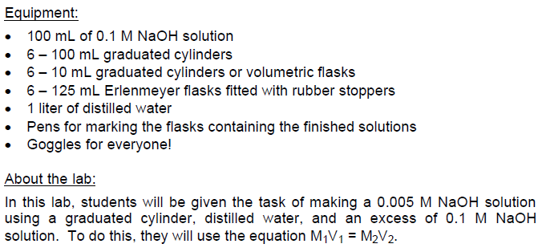
Procedure:
Write down your calculations and procuedure in a series of numbered and detailed steps:
____________________________________________________________________________________________________________________________________________________________________________________________________________________________________________________________________________________________________________________________________________________________________________________________________________________________________________________________________________________

