Why do solutions form or not form?

Station 1: Polar vs Nonpolar

Notes
1. What is the definition of polarity? __________________________________________________________________________________________________________________________________________________________________________
2. What is a polar molecule?
__________________________________________________________________________________________________________________________________________________________________________
a. Example of polar molecule:
b. Draw the line(s) of symmetry in this molecule.

3. What is a nonpolar molecule?
__________________________________________________________________________________________________________________________________________________________________________
a. Example of nonpolar molecule:
b. Draw the line(s) of symmetry in this molecule.

Draw the Lewis dot diagrams for the following molecules and identify the molecules as polar or nonpolar.
HBr | O₂ | CO₂ | H₂O
Polar OR Nonpolar? | Polar OR Nonpolar? | Polar OR Nonpolar? | Polar OR Nonpolar?
Multiple Choice Strategies

- Read the directions above the question completely and carefully
- Read the entire question at least twice
- Read all the choices completely and carefully
- Focus on the main concepts. What is the question asking you?
- Process of elimination
- Eliminate what you definitely know as incorrect
- Focus on what is most plausible
- Go with your first instinct
- Look for and underline the key words in the answers that make similar answers different or opposite
- Increase and decrease
- Watch out for questions with “only” in it
- Read and look for key information in the text and visual stimulus
- Names, labels, processes, categories
- Numerical values, arrows, symbols
- Symbolic representation

------------------------------------------------------------------------------------------------------------------------------------------

Check for understanding
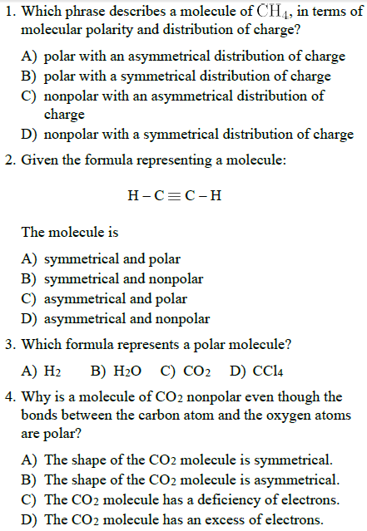

Station 2: Intermolecular Forces and Rates of Solution

Notes
1. What is the definition of intermolecular force? __________________________________________________________________________________________________________________________________________________________________________
2. What does the prefix “inter-“ stand for? ___________________________
3. What is hydrogen bonding?
__________________________________________________________________________________________________________________________________________________________________________
4. Draw a particle diagram that illustrates hydrogen bonding between at least 5 water molecules.

5. Explain how the following factors affect the rate of a solution?
Size of particles: ____________________________________________________________________________________________________________________________________________________________
Stirring:
____________________________________________________________________________________________________________________________________________________________
Amount of solute already dissolved:
____________________________________________________________________________________________________________________________________________________________
Temperature:
____________________________________________________________________________________________________________________________________________________________
Multiple Choice Strategies

- Read the directions above the question completely and carefully
- Read the entire question at least twice
- Read all the choices completely and carefully
- Focus on the main concepts. What is the question asking you?
- Process of elimination
- Eliminate what you definitely know as incorrect
- Focus on what is most plausible
- Go with your first instinct
- Look for and underline the key words in the answers that make similar answers different or opposite
- Increase and decrease
- Watch out for questions with “only” in it
- Read and look for key information in the text and visual stimulus
- Names, labels, processes, categories
- Numerical values, arrows, symbols
- Symbolic representation

------------------------------------------------------------------------------------------------------------------------------------------

Check for understanding
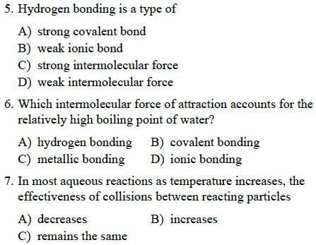
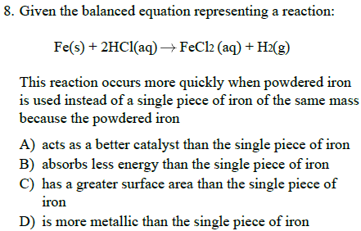

Station 3: What is a solution?

Notes
1. Salt water solution example broken down…
- What type of bonding is going on in NaCl? ____________________________
- What type of compound is NaCl? ____________________________
- What type of bonding is going on in H₂O? ____________________________
- What type of compound is going on in H₂O? ____________________________
- What type of molecule is H₂O? ____________________________
- When NaCl is added to H₂O, what happens to the Na⁺ and Cl⁻ ions with respect to the H₂O molecules?
______________________________________________________________________________________________________________________________________________________________________________________________________________________________________________________
2. Dissolving occurs when the solvent is ____________________________.
3. What is dissociation? __________________________________________________________________________________________________________________________________________________________________________
4. Draw a particle diagram that shows table salt dissociating in water. Label all parts of the diagram.

5. What are the five types of solutions? Give an example of each.
Type of solution | Example
Multiple Choice Strategies

- Read the directions above the question completely and carefully
- Read the entire question at least twice
- Read all the choices completely and carefully
- Focus on the main concepts. What is the question asking you?
- Process of elimination
- Eliminate what you definitely know as incorrect
- Focus on what is most plausible
- Go with your first instinct
- Look for and underline the key words in the answers that make similar answers different or opposite
- Increase and decrease
- Watch out for questions with “only” in it
- Read and look for key information in the text and visual stimulus
- Names, labels, processes, categories
- Numerical values, arrows, symbols
- Symbolic representation

------------------------------------------------------------------------------------------------------------------------------------------

Check for understanding
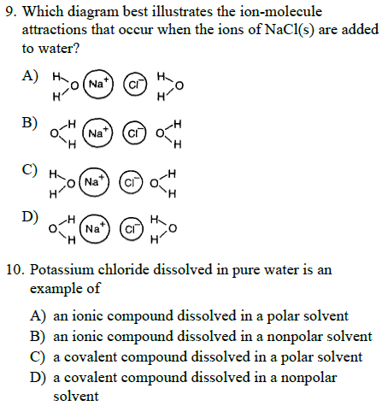
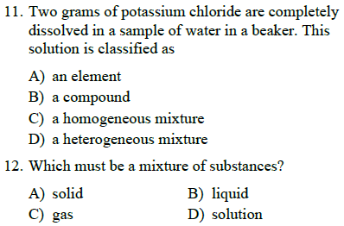

Station 4: Solubility Factors

Notes
1. What is the definition of solubility? _____________________________________________________________________________________2. What is the difference between soluble and insoluble? __________________________________________________________________________________________________________________________________________________________________________
3. When mixing two substances, a solution will form if “like dissolves like”. What does the phrase “like dissolves like” mean? __________________________________________________________________________________________________________________________________________________________________________
4. The FIRST solubility factor depends on the nature of the reactants (solute and solvent).
Looking at the following table as a grid, determine if mixing the two substances would be soluble or insoluble.
 | Nonpolar solvent | Polar solvent
Nonpolar solute
Polar solute
Ionic solute

5. The SECOND solubility factor depends on the temperature.
What is the relationship of temperature and solubility for solids and gases?
Solids:_______________________________________________________________________________________________________________________________________________________
Gases:_______________________________________________________________________________________________________________________________________________________
6. The THIRD solubility factors depends on pressure, but only relates to ___________________.
What is the relationship between pressure and solubility for gases?
Gases:_______________________________________________________________________________________________________________________________________________________
Multiple Choice Strategies

- Read the directions above the question completely and carefully
- Read the entire question at least twice
- Read all the choices completely and carefully
- Focus on the main concepts. What is the question asking you?
- Process of elimination
- Eliminate what you definitely know as incorrect
- Focus on what is most plausible
- Go with your first instinct
- Look for and underline the key words in the answers that make similar answers different or opposite
- Increase and decrease
- Watch out for questions with “only” in it
- Read and look for key information in the text and visual stimulus
- Names, labels, processes, categories
- Numerical values, arrows, symbols
- Symbolic representation

------------------------------------------------------------------------------------------------------------------------------------------

Check for understanding
