Equilibrium Simulation

- Go to http://phet.colorado.edu.
- Click on “Play With Sims,” then find the chemistry section, and click on “Reactions and Rates.”
- Click Run Now.
- Choose the “Rate Experiments” tab. Click the green plus sign to view the PE graph for the reaction, and the pie option under Options to view a Pie graph of the reaction. You will see this:
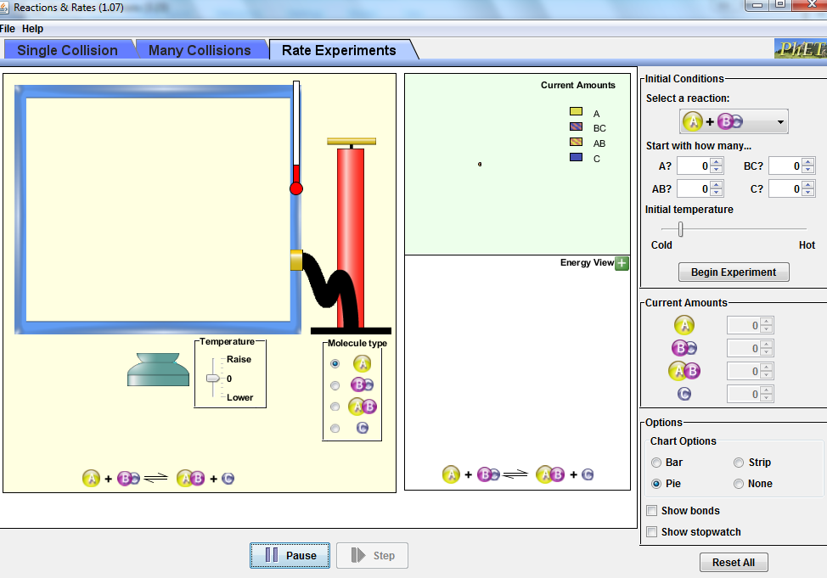
Click here to view a pie graph of the process.
PE
Click the green + to open Energy View which shows a PE graph.
PE

Experiment 1: Changes in Concentration
- In the reaction A + BC AB + C, identify the products and the reactants
  - Reactants: __________________
  - Products:___________________
- On the top right, under Initial Conditions, select the A + BC reaction with a yellow A. Based on the graph displayed under the Energy View, is this an endothermic or exothermic reaction? ____________________________________________________________________
- In the Initial Conditions section, under start with how many, input 40 “A” and 40 “BC” molecules.
- At the bottom right of the screen, click Show stopwatch. Click begin experiment and start the stopwatch. When the stopwatch reads 1500 (it runs really quickly!) pause the experiment and record how many A, BC, AB, and C molecules there are in table 1 below:
TABLE 1
A | BC | AB | C

- Pump in 10 more “A“ molecules into the container. You can add these using the controls under the current amounts section.
- Reset the stopwatch and un-pause the experiment. Start the stopwatch and when it reads 1500, pause the experiment and record how many A, BC, AB, and C molecules there are in table 2 below:
TABLE 2
A | BC | AB | C

- Compared to the first table, what happened to the amounts of BC, AB and C molecules after you added more A molecules to the container (did they increase, decrease, or remain constant?)
  - BC:___________________________________________________
  - AB:___________________________________________________
  - C:____________________________________________________
- Click End Experiment and again input 40 “A” and 40 “BC” molecules. Click Begin Experiment and time it for 1500 “stopwatch” seconds, then pause the experiment. Record how many A, BC, AB, and C molecules there are in table 3 below:
TABLE 3
A | BC | AB | C

- Pump in 10 more “C” molecules into the container. You can add these using the controls under the current amounts section.
- Reset the stopwatch and un-pause the experiment. Start the stopwatch and when it reads 1500, pause the experiment and record how many A, BC, AB, and C molecules there are in table 4 below:
TABLE 4
A | BC | AB | C

- Compared to the table 3, what happened to the amounts of A, BC and AB molecules after you added more A molecules to the container (did they increase, decrease, or remain constant?)
  - A:____________________________________________________
  - BC:___________________________________________________
  - AB:___________________________________________________
- When you add something to the reactant side, what happens on the product side of the reaction?
- When you add something to the product side, what happens to the reactant side of the reaction?

Experiment 2: Temperature
- Click End Experiment and again input 40 “A” and 40 “BC” molecules.
- Click Begin Experiment and adjust the temperature until the red is half-way up the thermometer. When it is at that temperature, time it for 1500 “stopwatch” seconds and then hit pause. Record how many A, BC, AB, and C molecules there are in table 5 below:
TABLE 5
A | BC | AB | C

- Resume the experiment and increase the temperature until the thermometer is ¾ full. Time it for 1500 stopwatch seconds and then hit pause. Record how many A, BC, AB, and C molecules there are in table 6 below:
TABLE 6 (hotter temperature)
A | BC | AB | C

- Resume the experiment and decrease the temperature until the thermometer is ¼ full. Time it for 1500 stopwatch seconds and then hit pause. Record how many A, BC, AB, and C molecules there are in table 7 below:
TABLE 7 (colder temperature)
A | BC | AB | C

- Since this is an endothermic reaction, the complete equation is A + BC + heat AB + C
  - When you add heat, which is on reactant side, what happens
    - to the amount of reactants? (see tables 5 and 6)
____________________________________________________________________
    - to the amount of products? (see tables 5 and 6)
____________________________________________________________________
  - When you remove heat, which is on reactant side, what happens
    - to the amount of reactants? (see tables 6 and 7)
____________________________________________________________________
    - to the amount of products? (see tables 6 and 7)
____________________________________________________________________

