SYSTEMS IN NATURE: ENTROPY and ENERGY

Notes on Entropy =

Task: Number the following 5 pictures of teachers’ desks in order of increasing disorganization.

A. Mrs. Bonnell’s desk: _____________
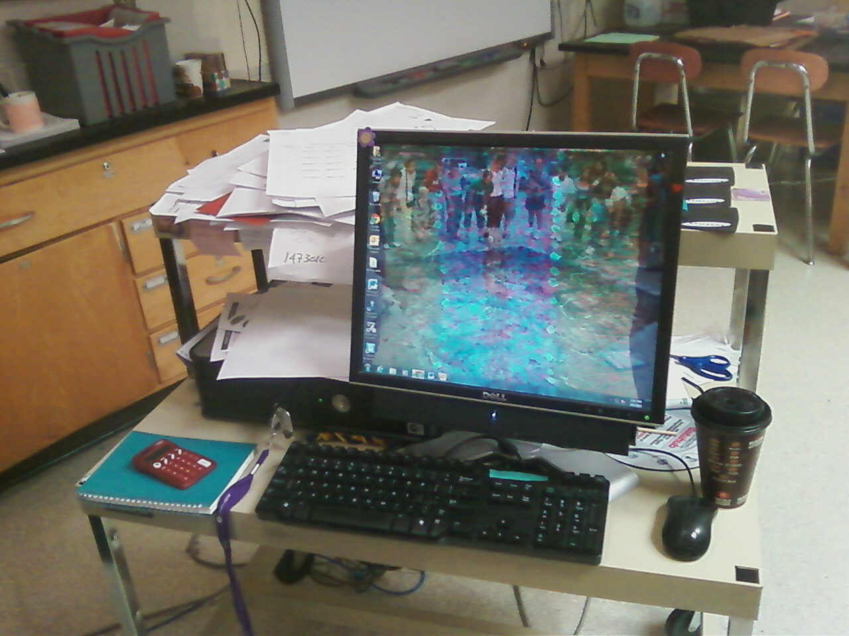

B. Ms. Burgstrom’s desk ______________
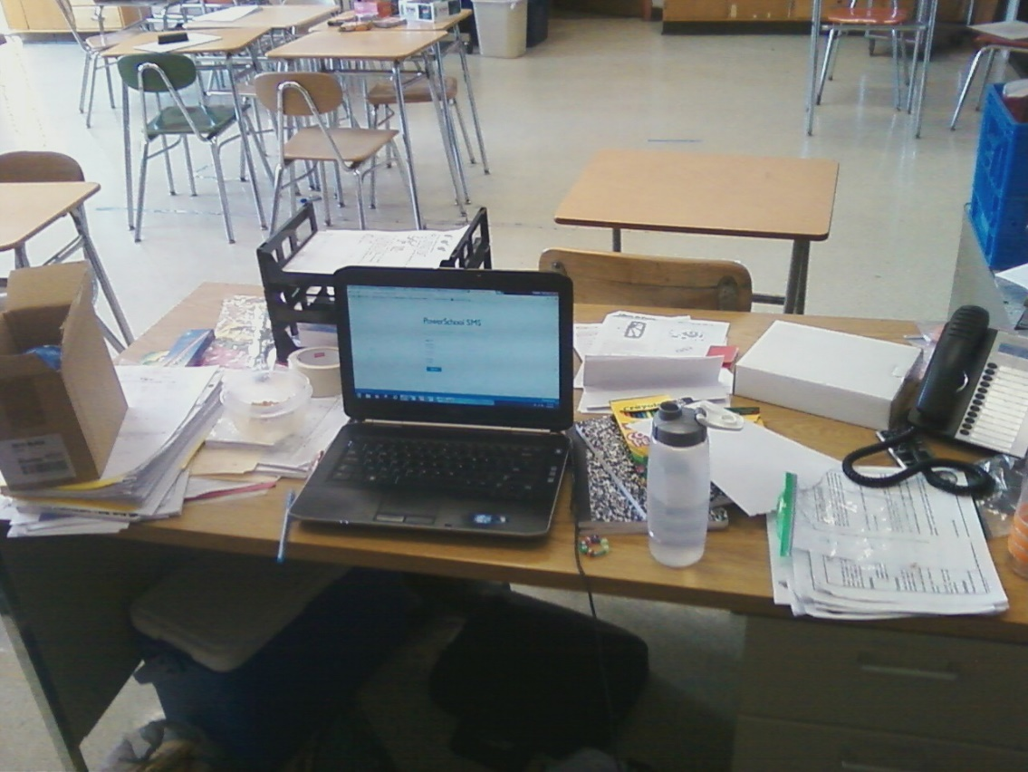

C. Mr. Caswell’s desk _____________
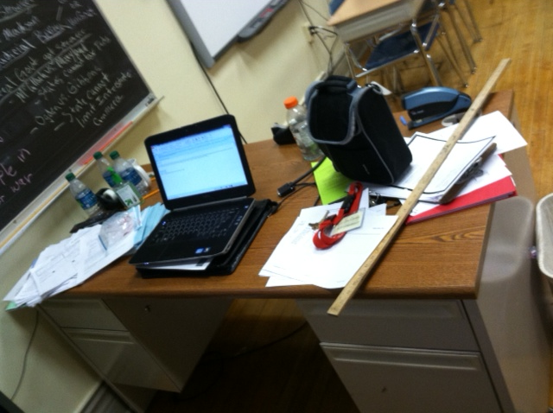

D. Mr. Moellering’s desk: _____________
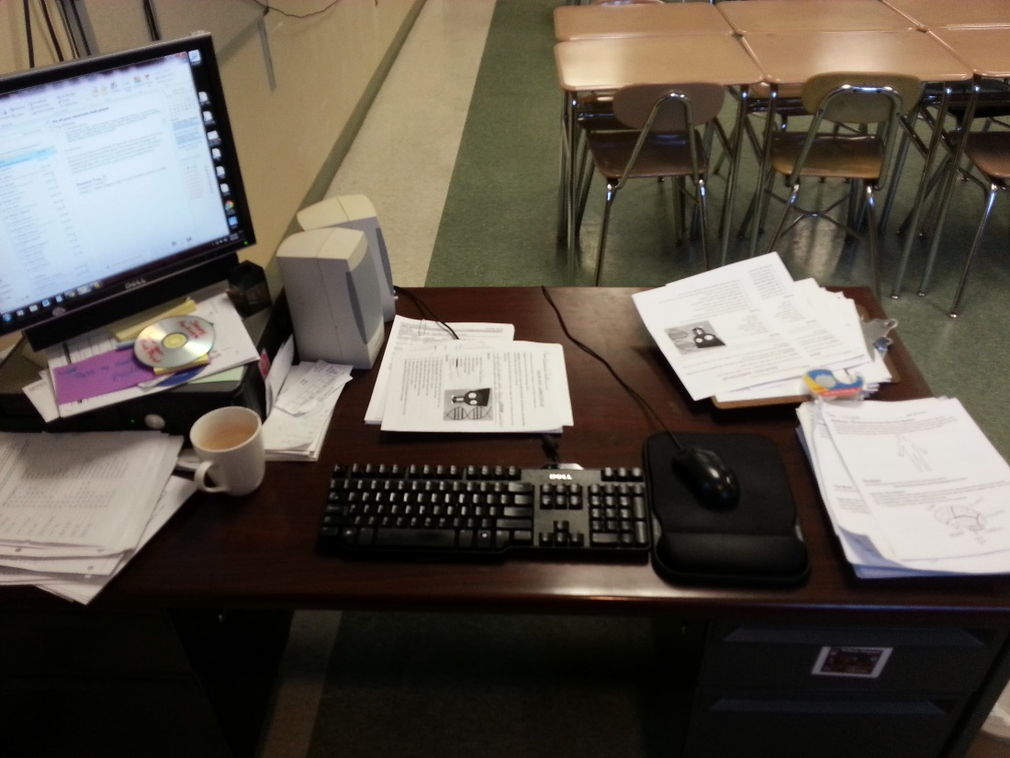

E. Ms. Reyes’ desk: __________
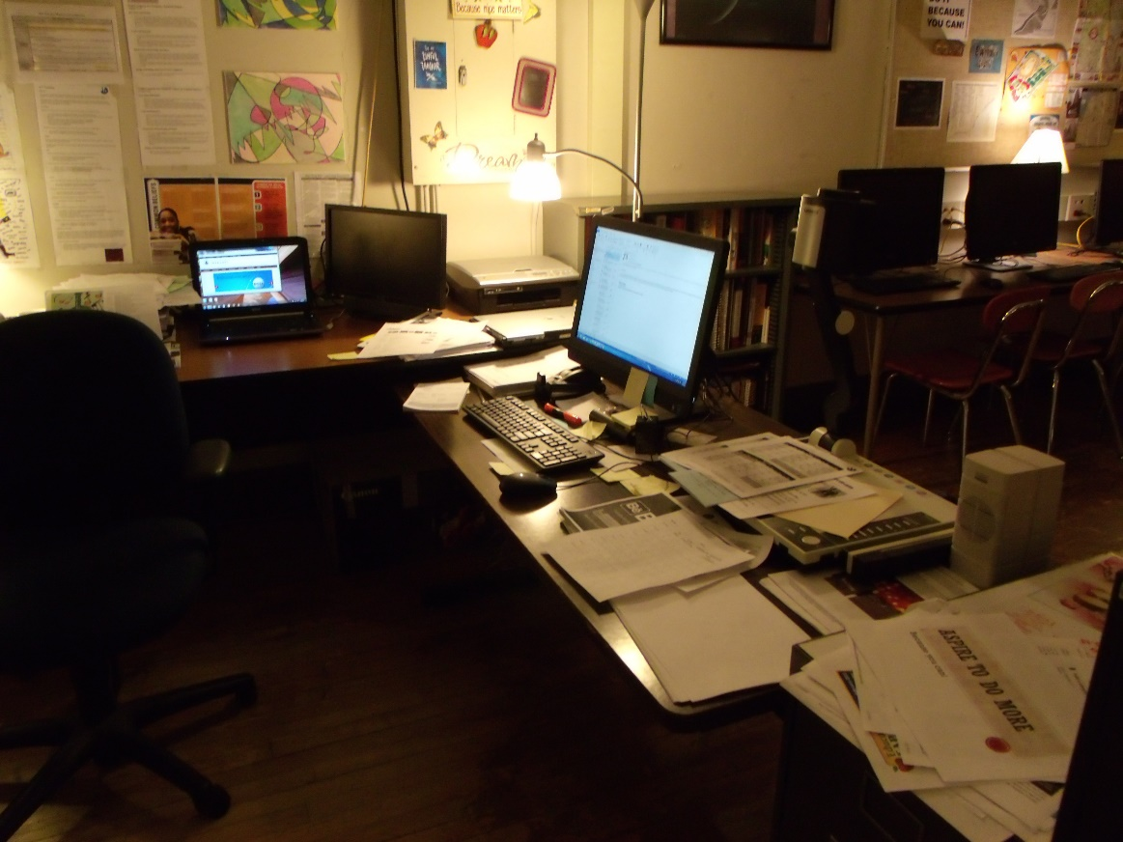

Questions:

1. I would nominate _________________________________ for the “Highest Entropy Award” because ___________________________________________________________________________________________________________________________________________________________.

2. Circle the correct answer choices:
Systems in nature prefer to have HIGH/LOW entropy and HIGH/LOW energy.
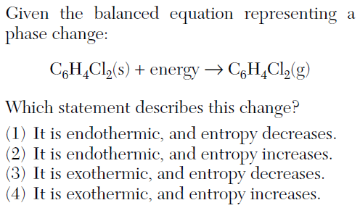
3. I chose this answer because…
________________________
________________________
________________________
________________________
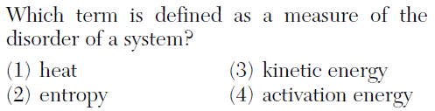
4. I chose this answer because…
________________________
________________________
________________________
________________________

When you have completed this packet, have it signed by your teacher for credit. ____________

