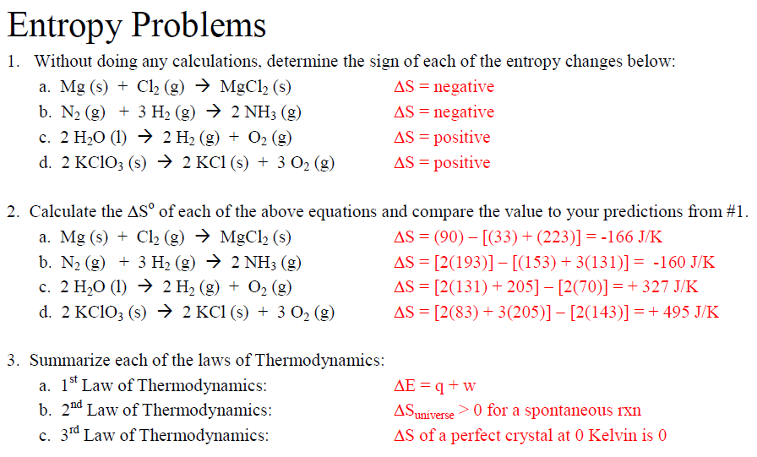

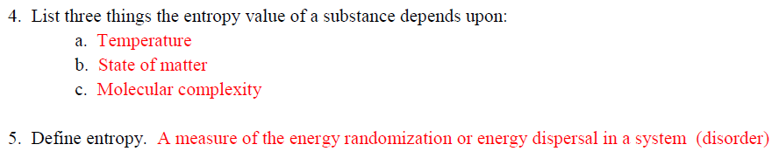

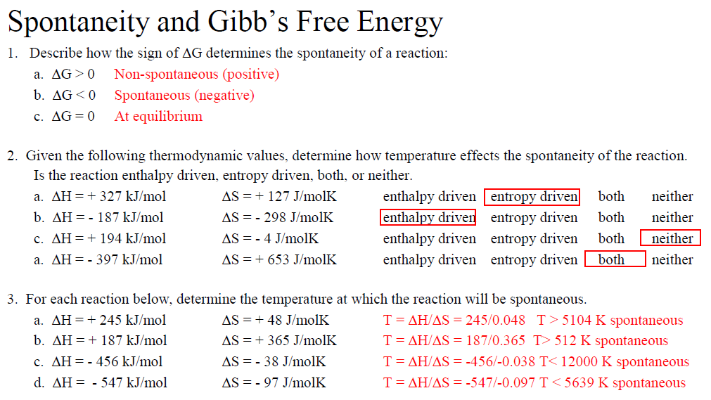

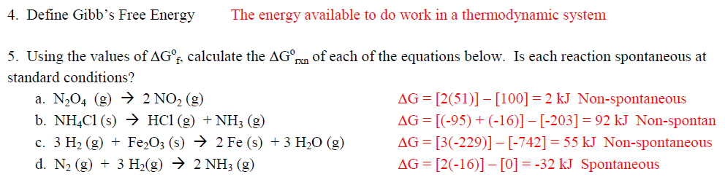

enthalpy driven entropy driven both neither

enthalpy driven entropy driven both neither

enthalpy driven entropy driven both neither

enthalpy driven entropy driven both neither