Spontaneous Process | First Law of Thermodynamics
Entropy | Standard Free Energy Change
Positional Probability | Standard Free Energy Change of Formation
Second Law of thermodynamics | Equilibrium Point
Free Energy | Reversible Process
Third Law of Thermodynamics | Irreversible Process
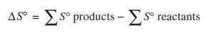 | 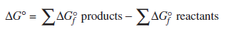
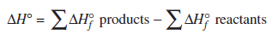
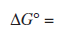 | 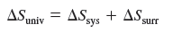
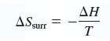
endothermic | exothermic
Thermodynamically favorable | Thermodynamically unfavorable

