6 Thermodynamics of rubber bands
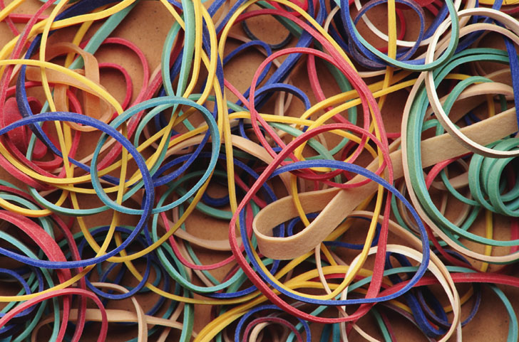
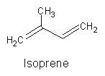
Rubber is composed of random-length chains of polymerized isoprene molecules. The poly(isoprene) chains are held together partly by weak intermolecular forces, but are joined at irregular intervals by covalent disulfide bonds so as to form a network. The intermolecular forces between the chain fragments tend to curl them up, but application of a tensile force can cause them to elongate. The disulfide cross-links prevent the chains from slipping apart from one another, thus maintaining the physical integrity of the material. Without this cross-linking, the polymer chains would behave more like a pile of spaghetti.
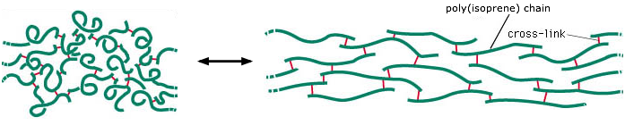
This image is adapted from one intended to show the structure
of the rubber-like protein elastin,
which is found in many organisms, including humans.
The ability of rubber bands and other elastic substances to undergo a change in physical dimensions in response to a change in the applied stretching force is subject to the same laws of thermodynamics as any other physical process. You can investigate this for yourself:

Experiment and Problem Example
Hold a rubber band (the thicker the better) against your upper lip, and notice how the temperature changes when the band is stretched, and then again when it is allowed to contract.
a) Use the results of this observation to determine the signs of ΔH, ΔG and ΔS for the process
rubber_{stretched} → rubber_{unstretched}

b) How will the tendency of the stretched rubber to contract be changed if the temperature is raised?

Why is rubber elastic?
When an ordinary material is placed under tension, the strain energy is taken up by bond distortions and is stored as electrostatic potential energy which rises very rapidly so as to greatly inhibit further elongation. In rubber-like polymers, this does not happen; the strain energy is instead stored as thermal (kinetic) energy.
Free polymer chains naturally tend to curl up in complex and ever-changing ways as thermal energy allows random bond rotations to take place. In a rubber-like material in its relaxed state, the portions of the polymer chains between cross-links are continually jumping between different randomly-coiled configurations.
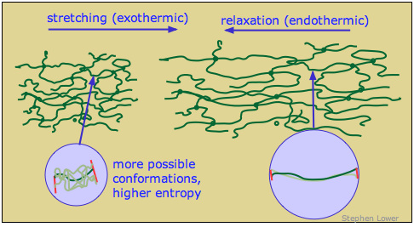
When the rubber is stretched, the polymer segments straighten out as the applied force overcomes the weak dispersion force interactions that caused the strands to curl. Each chain segment is pulled into an almost-straight conformation, thus greatly reducing the quantity of thermal energy it can store. The excess thermal energy spreads into the material and is lost in the form of heat. When the rubber relaxes, the polymer strands curl up again and soak up thermal energy.
The spontaneous contraction of rubber is largely an entropy-driven process. The number of energetically-equivalent ways of distributing thermal energy amongst the nearly-linear polymer chains of the stretched state of rubber is insignificant compared to those available when the chains are curled up in random ways, so the un-stretched form of rubber is statistically the most likely one by overwhelming odds.
As noted in part (b) of the above problem example, the gain in entropy when the rubber contracts drives ΔG more negative at higher temperatures. This means that a rubber band, held at constant tension in stretched state, will contract when it is heated.
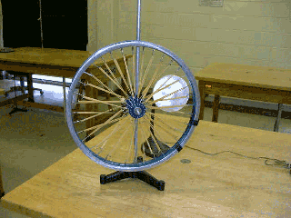
This fact can be put to use in an interesting way. Replace the spokes of a bicycle wheel with rubber bands, and shine a heat lamp on one side of the wheel. The contraction of the heated bands will shift the wheel off-center, causing it to rotate. This rotation will continue indefinitely as long as the heat source is present. The device has become a heat engine whose working "fluid" is rubber!
This recalls the classic perpetual motion machine design in which a wheel is caused to rotate by continually-shifting unbalanced weights. (The one depicted here uses hinged vials of mercury.) That, as we saw, would violate the Second Law by producing work in a cyclic process without degrading heat to a lower temperature. The rubber-band heat engine avoids this pitfall by absorbing heat from an external source on one side of the wheel, and releasing it at a lower temperature on the unheated side.
SUMMARY: Write a paragraph that explains the thermodynamics of rubber bands. Include at least 5 key words from your concept map in your explanation.

