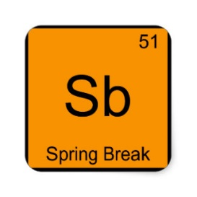
SPRING BREAK [CHEMISTRY EDITION]

DUE MONDAY, APRIL 6TH
1. Organic Chemistry Packet (attached)
--Read the notes and answer the multiple choice questions. Feel free to use the internet if you need extra resources.
2. Determine your Test Readiness: Diagnostic Exam (attached)
--Sit down in a quiet location for 2-3 hours and take this exam uninterrupted on your own. It will not be graded so there is no use in looking up answers while you take the test. BE HONEST WITH YOURSELF. You may use a calculator and your reference tables. We will use this test to come up with an individualized study plan for exam review.

DUE TUESDAY, APRIL 7TH
3. Chapter 18 Open Notes Quiz, Tuesday, April 7th
--You should read and take notes on chapter 18. There is no limit on the amount of notes you take.
--Notes must be hand written. Notes cannot be photocopied or typed.
--I will not ask you math questions on the quiz. Only conceptual questions. I will teach you how to balance equations and use the formulas when we return from break.
--Anything, and I mean anything, in Chapter 18 of Zumdahl is fair game for the quiz.

