Station 1: Introduction to Electrochemical Cells
Label the following diagrams for the two types of electrochemical cells:
Voltaic Cell
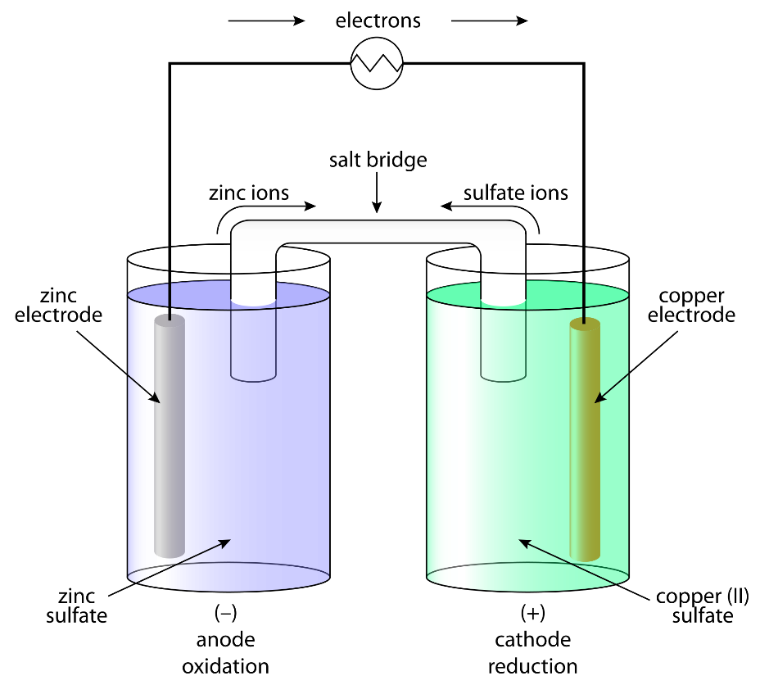

Electrolytic Cell
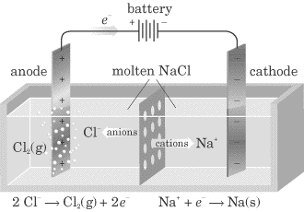

Station 2: Voltaic Cells
Voltaic Cell - a redox reaction whose two half-reactions are carried out separately, and the electrons given off by the oxidation half-reaction are used to power a device, and then given to the reduction half-reaction. ALSO CALLED A BATTERY (9v) OR CELL (AAA, AA, C, D)
How a Voltaic Wet Cell Works:
- Converts _____________ energy to ______________ energy by the use of a _______________________________
- __________________ move from the metal that is ____________ to the metal that is _____________
- Flow of electrons: ________________________________
Parts of a Voltaic Wet Cell:
Electrode:

Anode:

Cathode:

**REMEMBER:
Salt Bridge:

External Circuit:

Station 3: Electrolytic Cells
1. Define the parts of an electrolytic cell
Anode:

Cathode:

Battery:

Electrolyte:

Flow of electrons:

Parts of an Electrolytic Cell:
- Uses a ________________ redox reaction (the reaction _____________ occur on its own)
- Uses ____________ to____________________
- This process is called ________________________
- Used for:
1)
2)
3)

Station 4: Hydrogen Fuel Cell vs Electric Vehicles
1. Write the oxidation and reduction half-reactions for hydrogen fuel cells.
Oxidation Half-Reaction:
Reduction Half-Reaction:

2. Write the oxidation and reduction half-reactions for lithium ion batteries (electric vehicle power source).
Oxidation Half-Reaction:
Reduction Half-Reaction:

3. What are the benefits and limitations (disadvantages) of Hydrogen Fuel Cell vehicles?
Advantages:

Disadvantages:

4. What are the benefits and limitations (disadvantages) of Electric vehicles?
Advantages:

Disadvantages:

5. What type of electrochemical cell is the hydrogen fuel cell? ______________________________
6. What type of electrochemical cell is the lithium ion battery (electric vehicle)? _________________
7. Which of these vehicles occur spontaneously? _________________________________________

SUMMARY of Electrochemical Cells
Similarities
- 1.

- 2.

- 3.

- 4.

Differences
