Electrochemistry Quiz

Multiple Choice [1 point each]
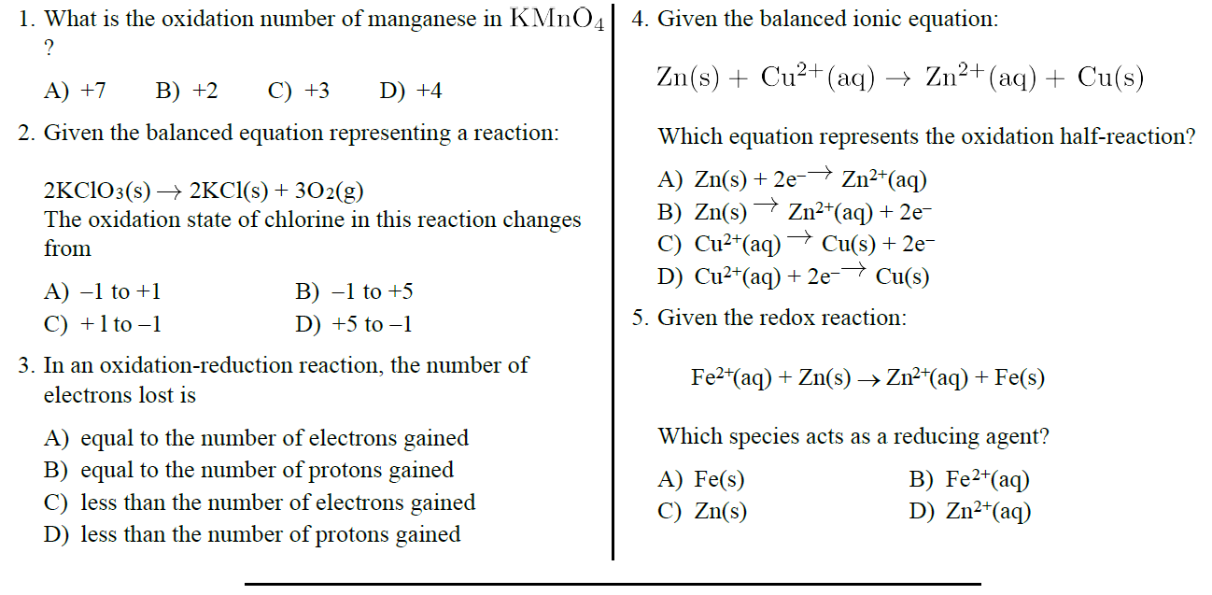

Short Answer
Directions: Write the half reactions for each of the redox reactions below and determine the oxidized reactant, reduced reactant, oxidizing agent, and reducing agent. [8 points each]

6.) Na + H₂O NaOH + H₂
Oxidation Half-Reaction: ____________________________________________
Reduction Half-Reaction: ____________________________________________
Oxidized: ________________ Reduced: ________________
Oxidizing Agent: ________________ Reducing Agent: ________________
7.) Zn + HNO₃ Zn(NO₃)₂ + NO₂ + H₂O
Oxidation Half-Reaction: ____________________________________________
Reduction Half-Reaction: ____________________________________________
Oxidized: ________________ Reduced: ________________
Oxidizing Agent: ________________ Reducing Agent: ________________

Directions:
A. Write the oxidation numbers for each element. [2 points]
B. Write the half reactions [4 points]
C. Label the oxidation and the reduction half-reactions [1 point]
D. Balance the equation according to the number of electrons. [2 points]

8.) ___ Ni + ___ Sn⁺⁴ ___ Ni⁺² + ___ Sn

**BONUS** [worth 2 points]
Would you prefer to drive a hydrogen fuel cell vehicle or an electric vehicle? To earn bonus points, provide two reasons for your choice based on the article from class.

