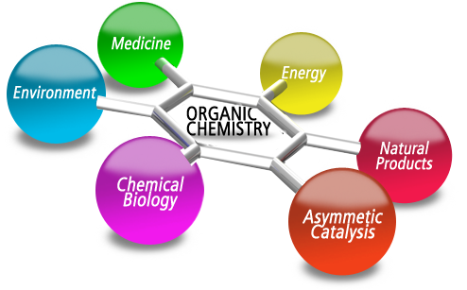

ORGANIC CHEMISTRY:
THE RELEVANCE TO YOUR WORLD (STATIONS)
Most of the products you use involve organic chemistry. Your computer, furniture, home, vehicle, food, and body contain organic compounds. Every living thing you encounter is organic. Inorganic items, such as rocks, air, metals, and water often contain organic matter, too.
STATION 1: CARBOHYDRATES, LIPIDS, PROTEINS
1. List at least 5 examples of foods that you eat that contain organic molecules.

2. Using the articles, choose one of your examples from above and explain how energy is obtained from carbohydrates, lipids, and proteins.

STATION 2: POLYMERS
1. What is a polymer?

2. Name at least 5 different examples of polymers that you may encounter in your everyday life.

3. Predict: What do you think polymerization is?

STATION 3: SOURCES OF ENERGY
1. Name at least three sources of energy that contain organic molecules and identify what this energy fuels.
Energy source _____________________________, Fuels _________________________
Energy source _____________________________, Fuels _________________________
Energy source _____________________________, Fuels _________________________

2. How does fractional distillation work?

STATION 4: SOAPS AND DETERGENTS
1. What is saponification?

2. Name at least 3 specific examples of soaps and detergents that YOU use in your everyday life.

STATION 5: PERFUMES AND COSMETICS
1. When you experience a smell, what is actually happening on the molecular level?

2. Name at least 3 different cosmetics/toiletries that you use in your everyday life.

3. Identify three smells and draw an organic molecule that causes that smell.
a. ______________________ b. ___________________ c. ___________________

4. Predict: Thinking on the molecular level, what causes the burning smell when you overcook bacon? (Hint: Ashes are made of pure carbon)

SUMMARY
Create a mini-poster on the back of this page or on a separate page so I can hang it up, explaining to a misguided peer why it is sooooooo important to learn about organic chemistry. Really sell it. It does not have to have a ton of information, but you have to get your main point across. You must include at least 5 examples on your poster.

