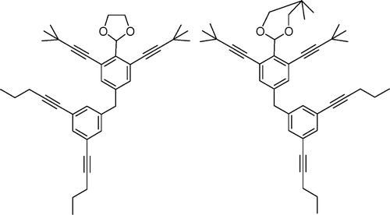
ORGANIC CHEMISTRY: Discovering Functional Groups
In organic chemistry, functional groups are specific groups of atoms or bonds within molecules that are responsible for the characteristic chemical reactions of those molecules. The same functional group will undergo the same or similar chemical reaction(s) regardless of the size of the molecule it is a part of.

Directions:
1. In each example, circle/box the functional group.
2. In the middle column, redraw just the functional group you circled in the example.
3. Use Table R in your reference tables to name the class of compound.
4. Go back and write the condensed structural formula for each organic compound. From left to right, write each carbon followed by the hydrogens/functional group it is bonded to.
Example (Circle the functional group) | Functional Group | Class of Compound
1 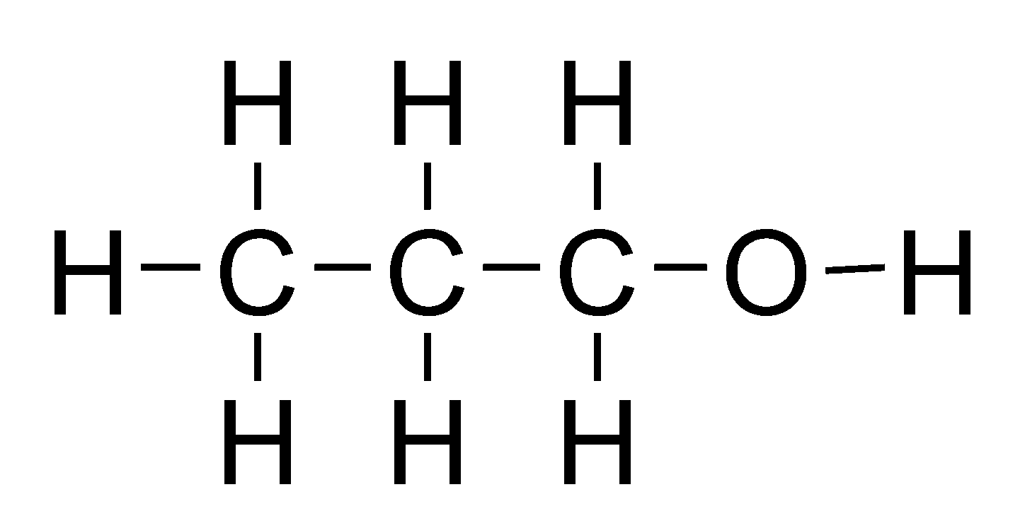
Condensed Structural Formula: CH₃CH₂CH₂OH
2 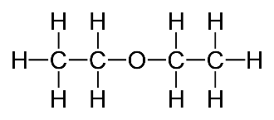
Condensed Formula:
3 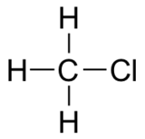
Condensed Formula :
4 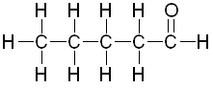
Condensed Formula :
5 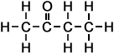
Condensed Formula :
6 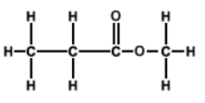
Condensed Formula :
7 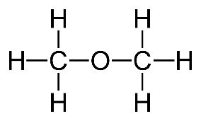
Condensed Formula :
8 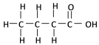
Condensed Formula :
9 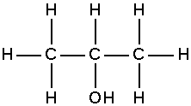
Condensed Formula :
10 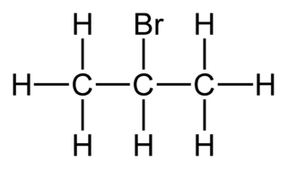
Condensed Formula :
11 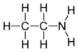
Condensed Formula :
12 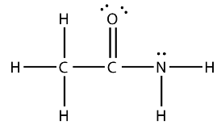
Condensed Formula :
13 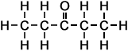
Condensed Formula :
14 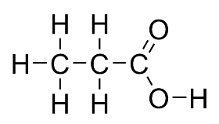
Condensed Formula :
15 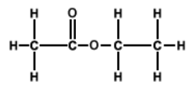
Condensed Formula :

