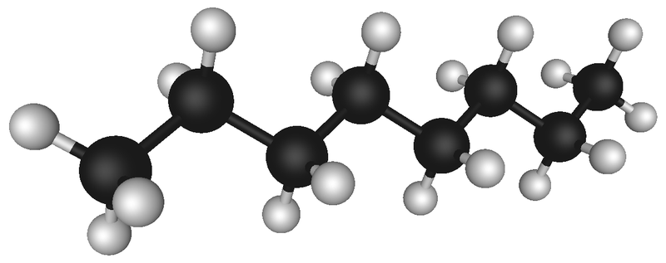
Naming Complex Hydrocarbons (TABLE R)
Use the molecular models around the room to fill in the table below.
Structural Formula | Condensed Structural Formula | Draw Functional Group | Class of Compound
1

2

3

4

5

6

7

8
9
10

11
12
13
14
15
16
17

