Lab 22: Organic Chemistry Reactions

This lab will focus on 3 different organic reactions: Saponification, Esterification, and Polymerization. The purpose of this lab is to observe organic reactions in order to better understand what differentiates one reaction from another.

# Pre-Lab

1. What are the three organic reactions you will study in this lab?

2. What is the purpose of this lab?

3. Based on the inside pages of this lab, write one characteristic for each organic reaction that makes it special/unique from other organic reactions.

Saponification:

Esterification:

Polymerization:

Have your teacher sign off on your pre-lab before you begin. _____________________

# [Image result for soap](http://www.google.com/imgres?imgurl=http://www.how-to-draw-funny-cartoons.com/image-files/cartoon-soap-007.jpg&imgrefurl=http://www.how-to-draw-funny-cartoons.com/cartoon-soap.html&h=367&w=500&tbnid=yYu6geAxC3uZQM:&zoom=1&q=soap&docid=b9Gi_TE8VkerVM&ei=8J9HVebkD8HFogTws4CgBQ&tbm=isch&ved=0CB0QMygBMAE)Organic Reaction 1: Saponification

The reaction in making soap (saponification) is a base (usually NaOH or KOH) hydrolysis of triglycerides to make three salts (soap) and glycerol. The molecules crystallize differently depending on the base used.

In this experiment we prepare soap from animal fat (lard) or vegetable oil. Animal fats and vegetable oils are esters of carboxylic acids; they have a high molecular weight and contain the alcohol, glycerol. Chemically, these fats and oils are called **triglycerides**. The principal acids in animal fats and vegetable oils can be prepared from the natural triglycerides by alkaline hydrolysis (saponification). You may also choose to add a scent to your soap by adding an essential oil. You can purchase the scent you want to add or isolate it from the natural source using a process of steam distillation.

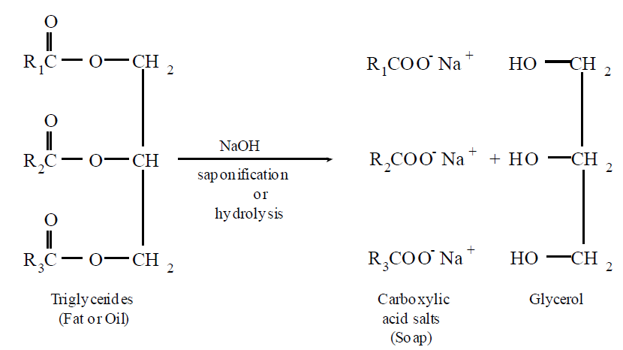

**Materials:**

The following items will be needed per group:

• two 500 mL beakers

• access to a microwave or hot plate

• thermometer

• access to an analytical balance

• 50 mL graduated cylinder

• stirring rod or spoon

• clear plastic wrap

• soap moulds (optional)

• vegetable shortening

• sodium hydroxide solution

• essential oils (optional)

**Procedure:**

**Step 1** Weigh out 112 g of vegetable shortening and place it in a large bowl or beaker.

**Step 2** Melt the vegetable shortening either in a microwave or on a hot plate. Check the temperature to see if thevegetable shortening is at 60 °C. If not, heat it until it reaches that temperature.

**Step 3** Using a 50 mL graduated cylinder, measure out 28 mL of the sodium hydroxidesolution and add it to the other bowl or beaker.

**Step 4** Check the temperature of the sodium hydroxide solution to make sure it is atleast 40 °C. If not, heat this solution until it reaches the desired temperature.

**Step 5** When the solutions are at the right temperature, carefully pour the sodiumhydroxide solution into the vegetable shortening, while stirring.

**Step 6** Mix the two solutions until the mixture thickens. Use a stirring rod or spoon andstir continuously. When the solution thickens, it will stay on top of the surfacewhen some of the solution is dripped from a spoon. Be sure not to stir it for toolong after it begins to thicken since then the mixture will not pour.

**Step 7** Once the solution begins to thicken, add the essential oils if desired and mixthem in. The essential oils will add a scent to the soap.

**Step 8** Pour the soap into the mould.

**Step 9** To prevent white ash from forming on the surface of the soap, cover the top with plastic wrap.

**Step 10** Wait at least three weeks for the soap to cure before using it. While waiting for the soap to cure, its pH can be testedperiodically using pH paper. The pH will decrease as all of the sodium hydroxide reacts with the fats. When thesoap has cured, its pH will be between 7 and 10. The closer the pH is to 7, the safer it is to use.

**Questions:**

1. What are three physical properties of the soap that you have created?

2. What are two characteristics that distinguishes the saponification reaction from any other organic reaction?

3. What type of compounds are the reactants in a saponification reaction? The products?

# [Image result for smell](http://www.google.com/imgres?imgurl=http://images.clipartpanda.com/nose-smell-clipart-Smell-2.gif&imgrefurl=http://www.clipartpanda.com/categories/nose-smell-clip-art&h=709&w=1142&tbnid=TngkWnmEUH9C2M:&zoom=1&q=smell&docid=TTyOpHKOo6wTuM&ei=yJ9HVYP7EY_SoASszIGYDQ&tbm=isch&ved=0CCAQMygEMAQ)Organic Reaction 2: Esterification

**Introduction:**

You have learned that organic compounds can contain different groups which allow different chemical reactions to take place. These different groups are called ***FUNCTIONAL GROUPS***. (They have a *function* and are the reason for the compounds specific physical and chemical properties.) This activity is about using two of these functional groups to make a third useful compound.

**An alcohol contains the –OH functional group attached to a carbon chain.**

For example:

**HO**-CH3 **HO**-CH2-CH3 **HO**-CH2-CH2-CH3

methanol ethanol 1-propanol

**An organic acid contains the –COOH functional group attached to a carbon chain.**

For example:



ethanoic acid propanoic acid butanoic acid

When an alcohol is reacted with an organic acid, an **ester** is produced and water is a by-product.

The general formula for an **ester** can be written as:

where R and R’ can be any C group (alkyl group).



Low molecular weight esters have pleasant odors and are responsible for many distinctive odors in fruits and flavorings. Esters can be readily prepared from an organic acid and an alcohol. Generally this reaction is catalyzed by strong acids.

+ R’-OH H2SO4 + H2O

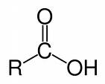

organic acid alcohol ester water

R, R’ = any alkyl group

**Sulfuric acid** is used as a ***catalyst*** for this reaction because it also serves as a dehydrating agent (it removes the water that is produced). Some ester structures are shown on the next page.

**Procedure**: Analyze the organic molecules below in the data table. Circle the functional group in the structural formula and classify that compound in the last column.

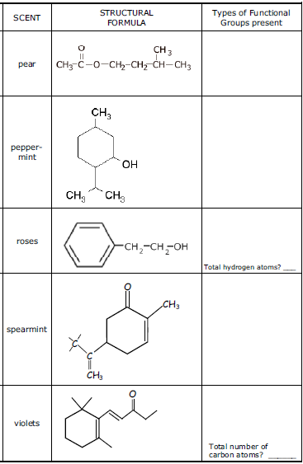**Data Tables**:

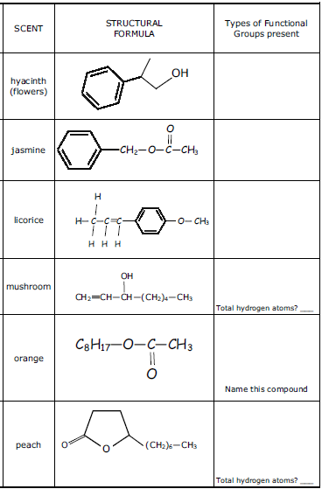

**Questions:**

1. Based on the introduction, what is the **structural formula for the ester** that formed in the introduction reaction?

2. Using structural formulas, write the **complete equation** for the introduction esterification reaction.

3. Using **condensed formulas**, write the complete equation for the introduction esterification reaction.

4. Choose an ester from the data tables. Draw the esterification reaction for that molecule from the data table. Use the introductory information to guide you.

*Label the organic acid, the alcohol, the ester, and the water.

5. Why is esterification known as a **dehydration reaction**?

# [Image result for basic polymerization reaction](http://www.google.com/imgres?imgurl=http://www.docbrown.info/page04/OilProducts/PVCform.gif&imgrefurl=http://www.docbrown.info/page01/ReactionTypes/ReactionTypes.htm&h=92&w=424&tbnid=tiCAMxsxbgZCJM:&zoom=1&q=basic+polymerization+reaction&docid=j23J2zYM3PytRM&ei=dJ9HVZfPOsfooAS5i4GYCA&tbm=isch&ved=0CEoQMygmMCY)Organic Reaction 3: Polymerization

**Introduction:**

Polymers are a large class of materials consisting of many small molecules (called monomers) that can be linked together to form long chains, thus they are known as macromolecules. The picture at the top of the page is a short section of such a chain. A typical polymer may include tens of thousands of monomers. Because of their large size, polymers are classified as macromolecules.

Unmatched in the diversity of their properties, polymers such as cotton, wool, rubber, Teflon(tm), and all plastics are used in nearly every industry. Natural and synthetic polymers can be produced with a wide range of stiffness, strength, heat resistance, density, and even price. With continued research into the science and applications of polymers, they are playing an ever increasing role in society.

**Procedure**:

1.) Teacher will do this… Create a polymer by mixing 8 grams of Borax with 200 mL of warm water. Stir until the borax is dissolved.

2.) Let this solution cool to room temperature.

3.) In a paper cup, add white glue up to the line on the cup. Then add 15 mL of water and thoroughly stir the glue and water. (If you would like to add color to the glue, add a few drops of food coloring to the glue-water mixture.)

4.) Mix 15 mL of the Borax solution with the glue. Stir for 2-3 minutes until the water is absorbed.

5.) You may keep your polymer in a baggie when you are done. Otherwise, discard it in the trash.

**Questions**:

1.) What are the characteristics of the polymer that you have created?

2.) How do the properties of the polymer differ from the properties of the plain glue?

3.) What could have happened on the molecular level to cause the change in consistency?

# Reactions Summary

Using your notes, the practice questions, and this lab, come up with a way to remember the defining characteristics of each organic reaction. Create your own “cheat sheet” for remembering the different reaction types.

|  |  |  |  |
| --- | --- | --- | --- |
| **Organic Reaction** | **Definition/Purpose of Reaction** | **Characteristics of Reactants** | **Characteristics of Products** |
| 1. Substitution |  |  |  |
| 2. Addition |  |  |  |
| 3. Combustion |  |  |  |
| 4. Fermentation |  |  |  |
| 5. Saponification |  |  |  |
| 6. Esterification |  |  |  |
| 7a. Addition Polymerization |  |  |  |
| 7b. Condensation Polymerization |  |  |  |

Have this completed page signed by the teacher. ______________