Nuclear Reactions: Wayyyyy more energy than chemical reactions!
Reaction 1: Nuclear Fission Reaction
Nuclear Fission:

Examples:
a.

b.

c.
Why do you think the above reactions are called nuclear fission? What key characteristics of this reaction help you determine this is a fission reaction? (Identify at least 2)

Reaction 2: Nuclear Fusion Reaction
Nuclear Fusion:

Examples:
a.

b.

c.
Why do you think the above reactions are called nuclear fusion? What key characteristics of this reaction help you determine this is a fission reaction? (Identify at least 2)

Reaction 3: Natural Transmutation
Natural Transmutation:

a.

b.

c.
Why do you think the above reactions are called natural transmutation? What key characteristics of this reaction help you determine this is a fission reaction? (Identify at least 2)

Reaction 4: Artificial Transmutation
Artificial Transmutation:

Examples:
a.

b.

c.
Why do you think the above reactions are called artificial transmutation? What key characteristics of this reaction help you determine this is a fission reaction? (Identify at least 2)

Directions: Identify the nuclear reaction type for the following equations. Then determine if mass is conserved.

Nuclear Equation | Nuclear Reaction | Mass conserved?
1 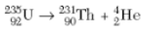
2 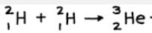
3 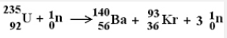
4
5 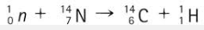
6 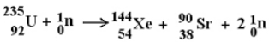
7 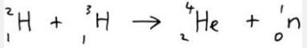
8 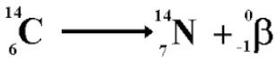
9
10

Teacher signature for completion _________________________

